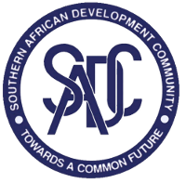

SADC Inception Workshop for the
Establishment of the Regional TFCA Network

September 25-26
Johannesburg, South Africa
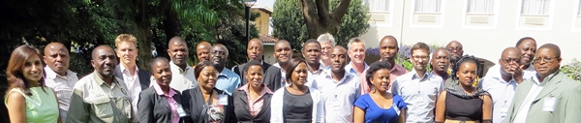
Funded by
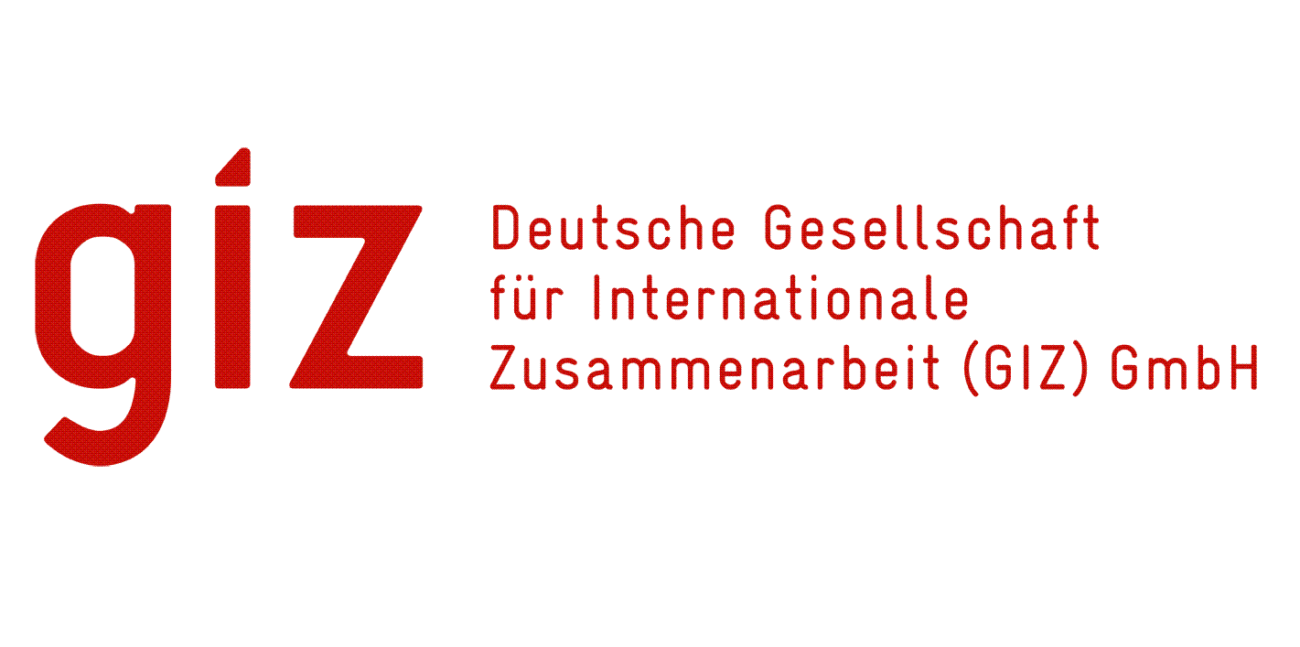

Workshop Report (Draft)
prepared by
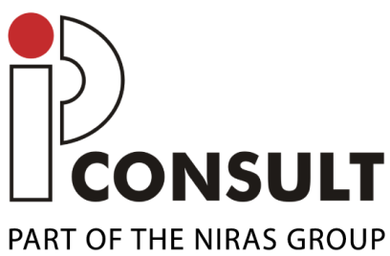


October 2013
Table of Contents
Abbreviations 3
0. Summary 5
1. Context and background 7
1.1 Inception Workshop for networking 7
2. Welcoming remarks and official opening 8
3. Overview of the SADC TFCA Programme 8
4. Setting the Scene 11
5. Sharing experiences across TFCAs 12
5.1 Group 1: Governance, legal provision, policy harmonisation 12
5.2 Group 2: Law enforcement and conservation management 14
5.3 Group 3: Promotion of tourism, community involvement, benefit sharing and financing 15
5.4 Group 4: Research, Monitoring and Evaluation 17
6. Common challenges and learning priorities 18
7. Lessons and Experiences from other networks 19
7.1 Overview of Networks and other forms of cooperation 19
7.2 Examples of other networks 21
7.2.1 Regional network: Southern African CBNRM forum (SACF) 21
7.2.2 Regional TFCA network: AHEAD-GLTFCA 21
7.2.3 Global networks: IUCN 22
8. Appropriate approaches, structures and institutional arrangements for learning together across TFCAs and within TFCAs 23
8.1 Membership of the network 23
8.2 Governance of the network 23
8.3 Tools for networking – the SADC TFCA Portal 24
9. Planning Ahead 24
9.1 Six Month Activity Plan 24
9.2 Financing 25
10. Other IUCN presentations 28
11. Closure of the workshop 28
Annex 1: Agenda of the workshop 29
Annex 2: List of attendees 31

Abbreviations
AHEAD Animal and Human Health for the Environment And Development
AWF African Wildlife Foundation
BIOPAMA Biodiversity and Protected Areas Management
CBO Community Based Organisation
CBNRM Community Based Natural Resource Management
CoP Community of Practice
DRC Democratic Republic of Congo
EU European Union
FANR Food, Agriculture and Natural Resources
GIZ Deutsche Gesellschaft für Internationale Zusammenarbeit
GLC Greater Lebombo Conservancy
GLTP Great Limpopo Transfrontier Park
GLTFCA Great Limpopo Transfrontier Conservation Area
GMTFCA Greater Mapungubwe TFCA
ICP International Cooperating Partner
IUCN International Union for the Conservation of Nature
KAZA Kavango Zambezi
KfW Kreditanstalt für Wiederaufbau
KNP Kruger National Park
KTP Kgalagadi Transfrontier Park
KZN Kwa-Zulu Natal
LC-Goba Lubombo Conservancy - Goba
LNP Limpopo National Park
M&E Monitoring and Evaluation
MAZA Malawi-Zambia
MOU Memorandum of Understanding
MS Member States
NGO Non Governmental Organisation
NP National Park
NRM Natural Resource Management
PA Protected Area
PPF Peace Parks Foundation
RISDP Regional Indicative Strategic Development Plan
SA South Africa
SACF Southern African CBNRM Forum
SADC Southern African Development Community
SANParks South African National Parks
SC Steering Committee
SNTC Swaziland National Trust Commission
TBC Transboundary Conservation
TC Technical Committee
TFCA Transfrontier Conservation Area
TORs Terms of Reference
TP Transfrontier Park
UN United Nations
WCPA World Commission on Protected Areas
WCS Wildlife Conservation Society
WTO World Trade Organisation
WWF World Wide Fund for Nature
ZAWA Zambia Wildlife Authority
ZIMOZA Zimbabwe, Mozambique, Zambia
ZIMPARKS Zimbabwe Parks and Wildlife Management Authority

Summary
Following a participatory process of investigation, analysis and discussion over two days, SADC Member States concluded the following:
- Themes most relevant in TFCA development:
- Governance
- Legal provision
- Policy harmonisation
- Cross border law enforcement
- Conservation management
- Tourism development
- Community involvement
- Benefit sharing
- Sustainable financing
- Research
- Monitoring and Evaluation
- Main challenges facing TFCA establishment and development:
- Developing a cross sectoral approach to TFCA development - nationally and regionally
- Effective governance of TFCAs at the level of
  - Institutions
  - Policies & legislation
- Sustainable financing mechanisms for TFCAs
- Enhancing community benefits and capacity development
- Demonstrating the value of TFCAs at the local, national and regional levels
- There is value added for TFCA development in cooperating through the establishment of a network which should for the moment, focus on:
- Finding common solutions to common challenges
- Sharing experiences and
- Developing a regional repository of TFCA related information.
- Subsequently, a SADC TFCA Network was established
under the auspices of SADC with the purpose of: Overcoming TFCA challenges through shared learning, knowledge management and collaboration
- Core Membership of the network shall be drawn from:
- National level: TFCA Focal Points/National Coordinators
- Local level : Agency Focal Points
- Regional level: International Coordinators for individual TFCAs
SADC Secretariat

- Each SADC MS will nominate Champions to drive both TFCA development and activities of the Network at the national level.
- A Steering Committee will provide strategic guidance to the network and report and advise the SADC Technical Committee (TC) on Wildlife on key recommendations and activities of the network. The committee comprises:
- Malawi (current Chair of SADC) - William Mgoola
- Zimbabwe (Vice Chair of SADC) - Alec Dangare
- Mozambique (immediate past Chair of SADC) - Afonso Madope
- SADC Secretariat - Bartolomeu Soto

- Activities of the network for the next six months shall focus on:
- Building relationships
- Data and content publishing
- Meetings
- Other key recommendations include:
- Advocating for the position of the SADC TFCA Focal Point to be filled on a priority basis
- Recommending the development of a specific SADC Protocol on TFCAs
- Currently some financing to kickstart the network is being provided by GIZ. However, in time, other sources of finances will need to be explored (including from Member States, ICPs, NGOs, etc) based on developed work plans and agreed upon deliverables from the network.

Context and background
The SADC Protocol on Wildlife Conservation and Law Enforcement (1999) defines a TFCA as “the area or component of a large ecological region that straddles the boundaries of two or more countries encompassing one or more protected areas as well as multiple use areas” and commits SADC Member States “to promote the conservation of shared wildlife resources through the establishment of TFCAs” (Article 4, objective 2f). In order to promote the establishment and development of TFCAs as a conservation and development model across the region, a SADC TFCA Programme (2013) has been proposed. The Programme has seven key component areas of which, Component 4 envisions the establishment of an information exchange, learning and innovation network which would facilitate the gathering, processing and dissemination of TFCA related information to TFCA stakeholders.
Key relevant activities required to achieve the stated outputs and objectives of this component as listed in the Programme are as follows:
- Document and disseminate innovative approaches in TFCA development and management
- Establish a central database on TFCAs
- Create a TFCA portal to link existing TFCA web-pages and other documentation
These activities and others would allow greater learning to take place within and between TFCAs and for good practices and important lessons to be drawn out from existing TFCAs, documented and shared across the region.

Inception Workshop for networking
German Technical Cooperation through GIZ is undertaking a project to support SADC Secretariat and SADC Member States in implementing the regional TFCA programme. In line with Component 4 of the proposed SADC TFCA Programme, the SADC-GIZ Project seeks to facilitate the establishment of a TFCA network to enable learning and information exchange within TFCAs, and between TFCAs.
In this regard, a workshop was organised by the SADC Secretariat with support from GIZ for the SADC Member States (MS) in Johannesburg, South Africa from 25-26 September 2013 with the following objectives:
- Share experiences across the different TFCAs and identify common challenges.
- Understand the advantages for learning together for TFCA development.
- Identify appropriate approaches for learning together across TFCAs and within TFCAs.
- Explore possible structures/institutional arrangements for learning together.
- Develop concrete plans and activities with clear commitments among members for continuous learning in the first six months.
The approach taken in designing and implementing the workshop was to facilitate maximum and active participation by attendees and enable a process of investigation, analysis, discussion and conclusion through which the outcomes are owned fully by the participants. Hence, the rationale in the design of workshop activities was to follow a stepwise process through plenary sessions, group work and presentations to meet the workshop objectives. The steps followed were:
- Exploring the current scenario in the SADC region across TFCAs, identifying achievements and challenges in key thematic areas for TFCA development
- Identifying common challenges across the SADC region in TFCA development
- Deliberating on the possible value added/opportunities created by learning together in addressing these common challenges
- Learning from examples of other networks – regional and global
- Determining what purpose should be served by SADC MS learning together with regards to TFCA development
- Considering institutional, management and operational arrangements including financing
- Prioritising resources and developing a six month work plan for the network
The following report is an account of this process.

Welcoming remarks and official opening
Malawi, the current Chair of the SADC, welcomed the representatives of the MS and thanked the Government of South Africa for hosting the workshop, the SADC Secretariat for organising it and GIZ for financing it.
Participants were reminded that the Kgalagadi Transfrontier Park between Botswana and South Africa was the first TFCA to be established in 1999 in SADC. Currently there are eighteen (18) TFCAs in SADC, covering more than 700,000 km² and at various stages of development. Four (4) TFCAs have international treaties, six (6) have Memoranda of Understanding and eight (8) are still in the conceptual stage.
Malawi emphasised the political will of SADC and its MS to promote TFCAs underlining their importance for socio-economic development and biodiversity conservation. As such, TFCAs are also considered a valuable tool to promote regional cooperation. In addition, the MS acknowledge the value of information exchange, processing and dissemination and as a result, this workshop was organised to deliberate on the establishment of a regional network for TFCA practitioners. After wishing the participants fruitful deliberations, the workshop was declared officially open.

Overview of the SADC TFCA Programme
The proposed SADC TFCA Programme (2013) was presented by the SADC TFCA Technical Advisor, the main elements of which are given below. The Technical Advisor reported that the Programme was scheduled to be presented to the SADC Ministers of Environment for approval on 3rd October 2013 in Maputo, Mozambique.
Principles and legal basis

TFCAs are established on the principles that natural resources that cross international borders are:
- Shared,
- Can contribute to biodiversity conservation on a landscape scale,
- Offer alternatives to enhance socio-economic development of rural communities.
The legal instruments that constitute the basis for TFCA development in SADC are:
- SADC Protocol on Wildlife Conservation and Law Enforcement (1999),
- SADC Protocol on Forestry (2002),
- SADC Protocol on Shared Water Courses (2002) and
- SADC Regional Biodiversity Strategy (2006).
Map 1: SADC TFCAs (Source: Peace Parks Foundation)
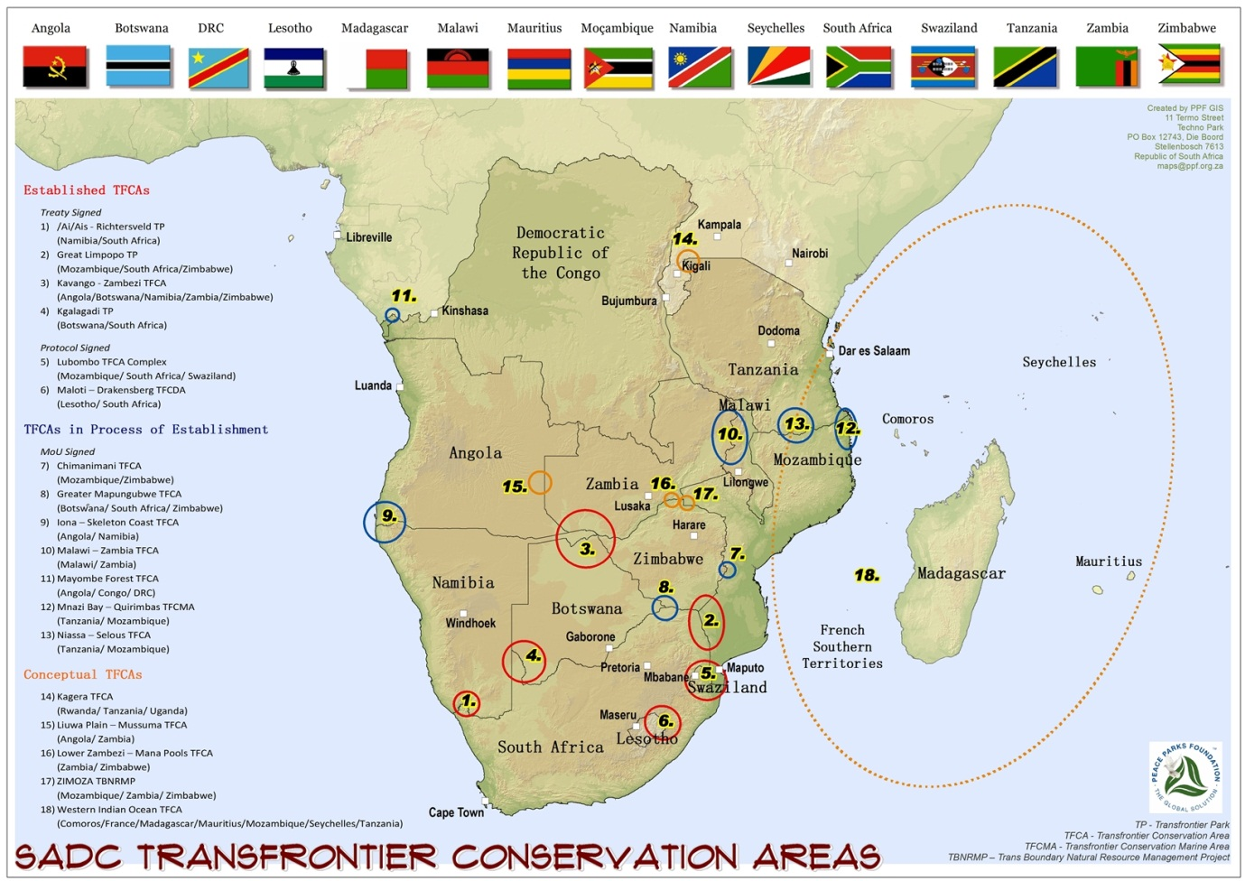

Vision:
“SADC, a model of community centred, regionally integrated and sustainably managed network of world class transfrontier conservation areas.”
Mission:
“A functional and integrated network of transfrontier conservation areas where shared natural resources are sustainably co-managed and conserved to foster economic and social development, tourism, and regional integration for the benefit of those living within and around TFCAs and mankind at large.”
Key Component Areas of the SADC TFCA Programme:
The programme contains seven (7) components with specific objectives, activities and results to be carried out at the regional, sub-regional and national levels.
- Component 1: Advocacy and harmonisation

- Component 2: Enhancement of financing mechanisms for TFCAs

- Component 3: Capacity building for TFCA stakeholders
- Component 4: Establishment of data and knowledge management systems

- Component 5: Enhancement of local livelihoods
- Component 6: Reducing vulnerability of ecosystems and people to the effects of climate change
- Component 7: Development of TFCAs into marketable regional tourism products
The two-day workshop refers to Component 4, the outcome of which was the establishment of a learning and information exchange network for TFCA practitioners.

Setting the Scene
Nine SADC Member States were represented at the workshop at the level of National TFCA Focal Points, other representatives from the lead and implementing agencies, and International Coordinators from individual TFCAs totalling 41 participants (a full participant list is attached in Annex 2). Of these, almost half had over five years of experience in TFCA establishment and development. Represented countries included:
- Angola
- Botswana
- Lesotho
- Malawi
- Mozambique
- South Africa
- Swaziland
- Zambia
- Zimbabwe
While discussing their expectations from the workshop, participants affirmed these broadly corresponded to the objectives of the workshop listed in Section 1.1.

Sharing experiences across TFCAs
Workshop participants listed and grouped key thematic areas that they considered most relevant to TFCA development as follows:
Key Thematic Areas:
Divided into these four groups, participants shared experiences from TFCAs of their selection to identify some key achievements or positive case studies as well as key challenges and shortcomings in those thematic areas. Below is a synopsis of the group discussions and presentations.

Group 1: Governance, legal provision, policy harmonisation
Case study 1: Lubombo TFCA
The Lubombo TFCA is a joint initiative of Mozambique, South Africa and Swaziland.
During plenary report back, it was noted that Lubombo comprises five sub TFCAs which are experiencing different levels of success, with some doing better than others.
Case study 2: ZIMOZA TFCA
ZIMOZA was conceptualised in the late 1990s to promote conservation and utilisation of shared natural resources between the borders of Zimbabwe, Mozambique and Zambia (ZIMOZA). However, as the figure below demonstrates, little progress has been made in its formal establishment.

Zimbabwe reported during plenary that a political decision has since been made that an agreement will be signed to formally establish ZIMOZA, thereby providing the legal basis for further development.

Group 2: Law enforcement and conservation management
Case study 1: GLTP and GLTFCA
The Great Limpopo Transfrontier Park straddles the boundaries of Mozambique, South Africa and Zimbabwe and has joint management committees and an International Coordinator in place to address issues of conservation, safety and security, finance, human resources, legislation and tourism. The harmonisation and integration of various policies to improve the collaborative management of the TFCA are currently underway. The GLTP Treaty (2002) allows for the development of cooperation agreements, one of which specifically focuses on protecting the elephant and rhino populations. This group discussed the issue of cross border law enforcement in the context of the acute rhino poaching crisis currently facing the TFCA. Emanating from the cooperation agreement are joint operational plans and cross-border protocols. The following are the strategies being utilised to tackle this prevailing threat:

Case study 2: Malawi-Zambia TFCAs (Nyika; and Kasungu – Lukusuzi components)
Discussions during plenary informed the workshop participants that the MAZA Treaty should hopefully be signed by the end of 2013. It was pointed out that there appears to be considerable ground level activity in the Nyika component of MAZA without a legal instrument, therefore demonstrating the possibilities for lessons that could be learnt and applied elsewhere in the region for those TFCAs that don’t yet have legal instruments. With regards to law enforcement challenges arising out of the restrictions on officials to cross international borders with firearms, the issue of law enforcement within a TFCA specifically needs to be addressed as countries do have allowances for people to enter their borders with firearms.

Group 3: Promotion of tourism, community involvement, benefit sharing and financing
Considering each of the thematic areas in this group, participants highlighted examples of projects/initiatives that are worth noting and are considered to positively contribute to TFCA development.

During plenary discussions, several other participants highlighted examples from their areas and countries which can be drawn upon for documentation and lessons learnt including cultural villages and a community owned lodge managed by private sector in Zambia; a community partnership park between local communities and ZAWA called Ngonye Falls in the Zambian component of KAZA; and Simalaha Wildlife Conservancy also in the Zambian component of KAZA which is an area put aside by the local community for wildlife restocking. However, it was noted that currently, most of these initiatives continue to remain national rather than regional/cross-border efforts.

Group 4: Research, Monitoring and Evaluation
Research
The group noted that of all the TFCAs, only GLTP has a Joint Research Policy. However, implementation is difficult due to different institutional arrangements, research priorities and available funding in each partner country. Research in TFCAs needs to be holistic to consider how the different themes interact with each other, and collaborative. Given that governmental funding for research tends to be minimal, the role of other organisations and networks becomes vital. In this context, establishing partnerships can be mutually beneficial, for example, between governments and academia, especially for baseline and strategic studies. The former are important to establish a baseline which can be used for monitoring purposes and as a future point of reference but the tendency is for development partners not to support this. Finally, while it is important for research to influence policy, the group recognised that policies and legislation are only worthwhile if they are effectively executed.
The group highlighted the following priority areas for research:

Monitoring and Evaluation (M&E)
The group advised that M&E should be a checks and balances system, which is used to identify where more effort and resources are required rather than a system for punishment. The ability to institutionalise M&E demonstrates long-term commitment as opposed to focusing only on planning. The group noted that generally M&E tends to be underplayed by most national governments and by default, in most TFCAs. However the need and importance for M&E is being recognised by some TFCAs as demonstrated by the following examples:
- Greater Mapungubwe TFCA - monitoring of keystone species for planning purposes
- KAZA TFCA - an ad hoc position for M&E has just been approved
- GLTP - an M&E exercise was undertaken two years ago at a Joint Management Board meeting

Plenary discussions noted that while partnerships should be encouraged and can be helpful especially to identify key research areas, it is just as important for research to remain independent and uninfluenced by competing agendas. The SANParks Research Report was mentioned as a possible example from which to draw lessons for future research communication efforts. The Transboundary Specialist Group Diagnostic Tool for TFCAs was also mentioned as a relevant and helpful reference to develop ad-hoc templates for SADC.

Common challenges and learning priorities
Based on the previous exercise, participants went on to identify the following five (5) common challenges that face TFCA establishment and development across the region:

- Developing a cross sectoral approach to TFCA development - nationally and regionally
- Effective governance of TFCAs at the level of
  - Institutions
  - Policies & legislation
- Sustainable financing mechanisms for TFCAs
- Enhancing community benefits and capacity development
- Demonstrating the value of TFCAs at the local, national and regional levels
Participants subsequently discussed the opportunities for and value of learning together, through a network or other forms of cooperation, with specific context to addressing the common challenges identified above. They listed the following opportunities available through “networking” in order of their current priority which they acknowledged, is likely to change over time.

Opportunities offered by learning together
Current prioritisation

Lessons and Experiences from other networks

Overview of Networks and other forms of cooperation
The presentation by the SADC-GIZ Project consultant team informed that a network is merely a form of cooperation in which a group of people seeks to connect with each other, guided by a common purpose such as a common interest, action, practise or circumstance. There are however, other ways to get things done, which include working alone, or working in small groups or triads. Each form of cooperation has advantages and disadvantages. The presentation went on to focus on Communities of Practise (CoP) and Networks – the two most common forms of cooperation.

Both networks and CoPs have three clearly defined elements; purpose, people and practise:
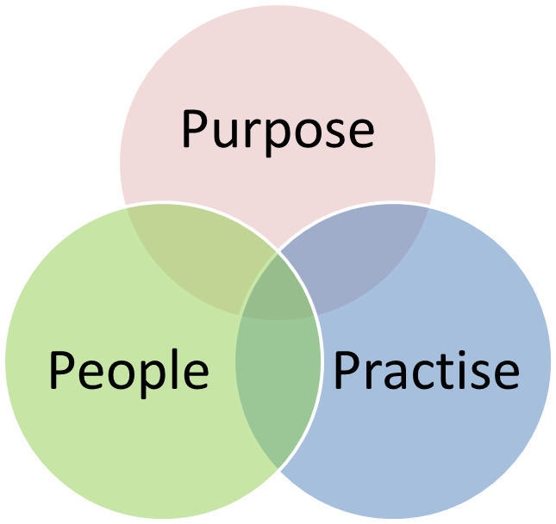

- What we care about? (purpose)
- Who cares about it? (people)

- What and how we do things together about it? (practise)

Of these, of critical importance is the value proposition or the purpose. This is the glue that incites personal investment from the members and binds them together. The purpose needs to be compelling, specific and relevant, allowing it to be clear and generate conviction. It may change over time.
The membership of the cooperation is its lifeblood and as such, it is essential to have the right people engaging with each other. Therefore, it is important to consider the profile of the proposed members. Finally, once the purpose for cooperation is determined, the membership needs to decide on how they will achieve it. Since resources are limited, it is important to prioritise activity orientations and attention to enable strategic focus – this too can evolve over time. Careful consideration of activities is important to maintain active engagement of the members.
Other facets that require attention when establishing a form of cooperation include issues of:

- Leadership
- Level of formality in operations and deliberations
- Requirement for facilitation services – both online and during face-to-face meetings
- M&E Framework to determine whether the group is delivering on their purpose
- Use of tools to effectively achieve purpose such as a website, database, newsletters, etc.
It is common to find a layering of purposes and forms of cooperation, for instance peer learning groups or focus working groups overlaid with CoPs, overlaid with a network. The consultant team emphasised that the name given to the form is not as important as the purpose, the people and the practise and that the form was just a tool and not the end goal in itself. The value of the cooperation is in seeing lessons learnt applied outside and thus it is important to periodically measure and evaluate the value added by the cooperation.

Examples of other networks
Several examples of other networks were presented at the workshop – full presentations of which are available on the CD with the workshop documentation:

Regional network: Southern African CBNRM forum (SACF)
The purpose of the Forum is to strengthen national CBNRM forums. Membership comprises the national CBNRM forums of Botswana, Malawi, Mozambique, Namibia, Tanzania, Zambia and Zimbabwe. Membership within these national platforms differs from country to country. SACF has a steering committee and thematic working groups with WWF Zambia playing the interim role of Secretariat. Key activities of SACF include organizational development, resource mobilisation, development of a knowledge management mechanism, and policy development and implementation. A number of tools have been developed by SACF for use by CBNRM practitioners and communities including manuals and a website. Funding for the inception phase of network establishment was provided by ICPs, with national governments providing some funding for national level activities. Other funds are raised through membership fees at the level of individual Forums. SACF is currently being registered as a legal entity in Zambia, which should position it better for resource mobilization activities.
Key challenges highlighted by the presentation included financial sustainability (national and regional), ill-defined membership, lack of optimal use of tools, lack of application of lessons learnt in local contexts, and the voluntary nature of participation resulting in limited availability and commitment of individuals.

Regional TFCA network: AHEAD-GLTFCA

This is a regional network for TFCA research and institutions.

- The Animal and Human Health for the Environment and Development (AHEAD) Programme of the Wildlife Conservation Society is essentially a convening and facilitative mechanism, which seeks to bring together players from often competing sectors to address challenges at the interface of wildlife health, livestock health and human health and livelihoods. This network started off as a working group for the Great Limpopo TFCA but has since grown into a multi-disciplinary, multi-sectoral network with over 300 members drawn from government, academia, private sector, development partners and NGOs. Since 2011, it has been a joint programme funded by the University of Pretoria and SANParks. The current emphasis is on human health; governance, law and policy; tourism and sustainable development. The network meets annually but also has thematic working group meetings. Since its establishment, twelve (12) projects have been funded in rural development and conservation through seed grants and 3 assessments on “one health” issues in the Limpopo National Park have been conducted. The network has a strong focus to institutionalize research through needs assessment in order to support governments in fulfilling their TFCA mandate.

Global networks: IUCN
The International Union for Conservation of Nature (IUCN) has many global networks or commissions with large and often diverse membership. For example, the World Commission on Protected Areas has over 1,700 members from 140 countries. Although they are volunteer networks, the Commissions have a chair and secretariat; specialist groups; working groups; and task forces. These different institutions can have their own leadership mechanisms through steering or executive committees. Activities vary and can include provision of strategic advice, capacity building and development of tools (manuals, databases, etc.). While these networks offer a powerful global body of technical expertise, being voluntary there are limitations to engagement and availability of the individuals. Financial constraints were also highlighted as a challenge.
A new initiative by IUCN entitled Biodiversity and Protected Areas Management (BIOPAMA) will focus on capacity building, development of regional observatories and networking in the African, Caribbean and Pacific group of countries. This means that there is considerable potential for complementary objectives to the TFCA network and geographical overlap. As such, participants of the workshop requested that SADC Secretariat explore greater possibility for synergy between the BIOPAMA programme and the TFCA network.
The figure below highlights the challenges identified by the different networks that presented during the workshop.

Appropriate approaches, structures and institutional arrangements for learning together across TFCAs and within TFCAs
Having considered the current challenges facing TFCA establishment and development in the SADC region, the value added for cooperating on TFCA related issues, and hearing from other networks, workshop participants concluded that
- there was value added for SADC TFCA development by learning together and sharing experiences; and
- A SADC TFCA Network should be established with the purpose of “overcoming TFCA challenges through shared learning, knowledge management and collaboration.”

Membership of the network
Participants agreed that the SADC TFCA Network should comprise of core and extended membership. Core membership should be drawn from:
- TFCA Focal Points/National Coordinators representing the national level in each MS
- Agency Focal Points from implementing agencies in each MS representing the local level
- International Coordinators for individual TFCAs representing the regional level
- SADC Secretariat also representing the regional level.
Assuming that each Member State nominates three (3) to five (5) core members of the network, a total of
45 -70 core members can be expected.
Although the participants agreed that the broader membership for the network should be drawn from other stakeholder groups in the region, specific details were not discussed beyond the resolution that each TFCA would submit a list of other stakeholders for consideration at the next meeting of the network.

Governance of the network
Since the network is constituted under the auspices of SADC, participants agreed that SADC operational procedures should be used to guide the establishment of a Steering Committee (SC). The SC will provide strategic guidance to network activities and report and advise the SADC Technical Committee (TC) on Wildlife on the recommendations from and activities of the network. Therefore, a SC was constituted based on the SADC Troika, comprising the current SADC Chair, the SADC Deputy Chair and the immediate previous Chair, as well as the SADC Secretariat:
- Malawi – William Mgoola
- Zimbabwe – Alec Dangare
- Mozambique – Afonso Madope
- SADC Secretariat – Bartolomeu Soto
Participants also agreed that the SADC MS should nominate specific Champions to drive and promote both TFCA development and the network at a national level. These Champions need not necessarily come only from government institutions but from other stakeholder groups as well.
Although the network will broadly be guided by SADC protocols and procedures, participants further agreed that its activities, operations and communications should not be burdened by too much bureaucracy or formality. Finally, they reaffirmed that as a MS initiative, the MS will continue to drive the process assisted by the SADC Secretariat, setting the agenda as per their needs.

Tools for networking – the SADC TFCA Portal
MINDQ from the consultant team for the SADC-GIZ Project presented an overview of the proposed web portal for the SADC TFCA network as mentioned in the SADC TFCA draft programme (2013). MINDQ explained that a TFCA Portal would be a cost effective way to share information and collaborate without members needing to be in the same geographic location or having face-to-face meetings all the time. The portal would be divided into two parts: a publicly available website used for information dissemination and a restricted section or “extranet” for use by core members which would be accessible via a username and password. The utility of the platform would increase by making it easy to use for non-technical personnel, and based on the ease with which members would be able to view, upload and download documents, post comments and discuss issues online. A number of features were presented but it was emphasized that through the use of modular architecture, the portal could start off being simple and basic, and slowly as the network evolved, so too could the portal. Of the features presented, of particular relevance are:
- Integration with social media such as YouTube and Twitter
- A TFCA database (directory of all TFCAs)
- A people’s directory for people working in TFCAs across SADC
- A document database
- An online discussion forum
- A project management facility
- A calendar facility marking all network events and other relevant events
- Links to feeds from other TFCA websites
With the advent of the Internet and modern technology, many other tools exist, which enable online collaboration. These include the ability for multiple users to simultaneously edit documents; store files in a virtual “cloud” making them accessible from anywhere in the world as long as there is internet connection; and organize and host online meetings. Mobile phone applications may also be considered viable, cost effective tools to network and collaborate based on ever expanding cellphone coverage and the more prominent use of smart phone technology. For instance, mobile phone technology may enable real time information feeds from the field and notifications from the TFCA website to field personnel. All these tools increase the ability for individuals to stay in touch, collaborate and share information with each other at minimal cost.

Planning Ahead

Six Month Activity Plan
Participants listed the following three priority areas on which to focus their activities for the coming six months given the limitation of time, human and financial resources:
- Building relationships amongst members of the network and other TFCA personnel to improve efficacy of implementation;
- Data and content publishing through the development of a web portal for the network as a regional repository for TFCA related information; and
- Organising further meetings (online and face-to-face) for the core members of the network.
Based on these areas, they then developed a six month activity plan as given below. Additionally, the network made the following key recommendations for the consideration of the SADC TC on Wildlife:
- To fill the position of the SADC TFCA Focal Point within the SADC Secretariat as soon as possible.
- To develop a specific SADC Protocol on TFCAs.
Concern was raised during the plenary discussion about whether the network would need approval of their activity plan by the SADC Minister of Environment to which the SADC Secretariat responded that this would not be necessary as the Protocol on Wildlife and Law Enforcement (1999) provided the MS to mandate to undertake activities to establish and develop TFCAs. The activities of the network would contribute towards this end. As agreed earlier, the SC of the network will report on its activities to the SADC TC on Wildlife regularly.

Financing
Participants were informed that financial support for activities of the network is currently available through the SADC-GIZ Project at least until mid-2015. The focus of this support is on:
- Development of a web portal under the auspices of SADC,
- Key meetings of the network,
- Facilitation, moderation and other forms of training for improving efficacy of the network,
- General administrative support for the network during the start-up phase.
Workshop participants recognised that they would need to explore additional sources of funding to support network activities based on agreed priorities and work plans beyond the initial start-up phase. Further, that there was need to explore possible linkages to other networks to avoid duplication of effort and access potential funding – such as IUCN’s BIOPAMA initiative.
Activity  Table 1: SADC TFCA Network activity plan | Deliverable | Timeline | Responsibility
      - Immediate next steps
- Submission of names by each MS for Champions and core network members | Core membership and Champions for the network confirmed | 30 September 2013 | MS
- Presentation of TFCA network at upcoming SADC Ministers of Environment meeting in Maputo, Mozambique | Noting by the SADC TC and SADC Ministers of Wildlife of the network | 3 October 2013 | SADC Secretariat
      - Organising further meetings (online and face-to-face) for the core members of the Network
- SC and network Champions to meet at the upcoming meeting in Maputo, Mozambique | First meeting of network SC | 30 September 2013 | SC
- Meeting of network core members |  | March 2014 | SC
      - Data and content publishing through the development of a web portal for the network as a regional repository for TFCA related information
- Portal Specification Document (cycle and approval by network members) | Approved Portal Specification Document | 30 November 2013 | MindQ, GIZ, SC
- Approval for funding for development of the portal | Funding made available for development | 30 November 2013 | GIZ
- Brand and logo design for the network | Approved brand and logo for the network | 31 December 2013 | SC, Core Members
- Content submissions by core members | Appropriate content submitted for the portal | 15 November 2013 | SC, Core Members
- Design and development of the public portal | Public portal available | 31 January 2014 | MindQ
- Design and development of the restricted portal | Restricted portal for core members | 24 March 2014 | MindQ
- Handover and administrator training (self-sufficiency) | Portal handed over and administrator trained | 31 March 2014 | MindQ
      - Building relationships amongst members of the network and other TFCA personnel
- Conduct stakeholder mapping for each TFCA | Stakeholder mapping document with comprehensive listing of stakeholders for each TFCA available | 31 December 2013 | National TFCA Focal Points, SADC-GIZ Consultant team
- Develop basic database of the stakeholders identified in 4.1 and core members | Information database available | 31 December 2013 | SADC-GIZ Consultant team
- Encourage more joint activities at various levels of TFCAs (e.g. monitoring, research, law enforcement, cultural activities) | More opportunities for stakeholders to interact & develop relationships | Ongoing | National TFCA Focal Points/ TFCA Coordinators
      - Other activities
- Explore synergies with the IUCN BIOPAMA initiative | Increased synergies with other initiatives | 30 November 2013 | SADC Secretariat
- Extended membership to the network considered for each MS and TFCA based on Activity 4.1 | Membership of network extended beyond the core | End of March 2014 | Network core members

Other IUCN presentations
Two other presentations were made by IUCN, unrelated to the TFCA network per se:
- Improving Protected Area Governance for Livelihood Security and Biodiversity in Southern Africa
- World Park Congress 2014: Parks, People Planet: Inspiring Solutions

The complete presentations are available on the CD with the workshop documentation.

Closure of the workshop
Malawi thanked the facilitators for guiding the participants through the workshop, the SADC Secretariat for their organisation, GIZ for their financial support and the participants for their active engagement and commitment. The “birth” of a SADC TFCA network was affirmed along with a clear roadmap for the next six months. With the hosts, South Africa, thanking the MS for the privilege of hosting the workshop, the workshop was officially closed.

Annex 1: Agenda of the workshop

Day 1, 25 September 2013

Time/hrs | Item | Format | Responsible
0730-0800 | Registration of participants | Complete registration form | GIZ / SADC Secretary /Administrator
0800-0810 | Welcoming Remarks and Official Opening | Speech / Presentation | SADC Chair (Malawi)
0810-0940 | Setting the Scene  - Introductions  - Expectations  - Objectives  - Programme | Facilitation | Facilitator
0940-1000 | Context & background: SADC TFCA Programme | Presentation | SADC Secretariat
1000-1030 | Tea break
1030-1230 | Current scenario in the different TFCAs  - Analysis & discussion  - Sharing across TFCAs | Group work | Facilitator
1230-1345 | LUNCH
1345 -1500 | Session I: Common Challenges & Areas to work/learn together
1345 -1500 | - Analysis of Common Challenges | Facilitation/Group Work | Facilitator
1345 -1500 | - Value Added by Learning together; value propositions and learning goals | Facilitation/Group Work | Facilitator
1500-1530 | Tea Break
1530-1730 | Session II: Lessons and Experiences from other networks
1530-1730 | - Overview of forms  - What is a network?  - Are there other options?  - What makes for a successful network? | Presentation | Consultant
1530-1730 | - Examples of networks  - A regional network  - A TFCA network | Presentations | - CBNRM Forum  - AHEAD GLTFCA network
1930 onwards | Cocktail reception
 | End of Day 1

Day 2, 26 September 2013
0800-0815 | Recap of Day One | Presentation | Patience Gandiwa
0815-1030 | Session III: Identification of appropriate forms for joint learning across & within TFCAs & institutional considerations
0815-1030 | - Drafting the Purpose | Plenary | Facilitator
0815-1030 | - Analysis of appropriate forms for joint learning | Plenary | Facilitator
0815-1030 | - Members of the network | Facilitation/Group work | Facilitator
0815-1030 | - Governance/management including partnerships & linkages | Facilitation/Group work | Facilitator
1030-1100 | Tea Break
1100 -1115 | - Examples of networks  - Global networks | Presentation | - IUCN
1115-1300 | Session IV: Planning for the first year
1115-1300 | - Tools for networking – TFCA Portal & mobile tools | Presentation | MINDQ
1115-1300 | - Setting priorities – what to focus energy on? | Plenary | Facilitator
1115-1300 | - Key events and activities | Facilitation/Group work | Facilitator
1300-1400 | Lunch Break
1400-1445 | Financial sustainability of the network | Plenary | Facilitator
1445-1515 | IUCN PA Governance Programme | Presentation | IUCN
1515-1530 | IUCN World Parks Congress | Presentation | SADC Secretariat
1530-1600 | Conclusions & Way Forward | Plenary | Facilitator
1600-1615 | Closure of the workshop | Speech | Host Country  SADC Chair
 | End of Day 2

Annex 2: List of attendees
Member State | Surname | First name | Organization | Designation | Work Tel | Cell | Work email
Angola | Nzuzi | Albertina | Ministry of Environment | Chief of Department | +244 924 991 915 | +244 924 991 915 | mawete08@hotmail.com
Botswana | Neo-Mahupeleng | Sennye | Dept. Of Wildlife and National Parks | Principal Wildlife Officer | +267 3971405 | +267 71477864 | sneo-mahupeleng@gov.bw  nsennye@yahoo.com
Lesotho | Nthama | Nthapeliseng | Department of Environment | Environmental Officer-Biodiversity Conservation (Parks) Division | +266 22311767  +266 22311139 | +266 58931899 | nnthama@gmail.com
Lesotho | Monyatsi | Mohau | Lesotho National Parks, Department of Environment | Park Manager | +266 585 37565  +266 246 61223 | +266 625 37656 | monyatsip@yahoo.com  nyayatsa.nyatsi@gmail.com
Malawi | Mgoola | William | Department of National Parks and Wildlife | Assistant Director | +265 1 759 832  +265 1 759 832 | +265 888 353 993 | wmgoola@wildlifemw.net  wmgoola@yahoo.co.uk
Malawi | Nyanyale | Samuel | Department of National Parks and Wildlife | Principal Parks and Wildlife Officer | +265 1 759 831  +265 1 759 832 | +265 888 876 743 | snyanyale@wildlifemw.net  Sam.nyale@gmail.com
Mozambique | Madope | Afonso | Ministerio do Turismo | Head of TFCA Unit |  | +258 823 222 270 | afonso.madope@gmail.com
Mozambique | Sebastiao | Pejul | National Administration of Conservation Areas/ANAC | Protected Areas Planner | +258 842977971  +258 21306212 | +258 828 304 620 | pejulsebastiao@gmail.com  pejulsebastiao@yahoo.com.br
South Africa | Kahatano | Deborah | DEA | Program Manager | +27 12 310 3734 | +27 82 078 5088 | dkahatano@environment.gov.za
South Africa | Maringa | Vongani | DEA | Assistant Director | +27 12 310 3368 | +27 82 779 2576 | vmaringa@environment.gov.za
South Africa | Mokganedi | Ernest | DEA | Director, TFCA Directorate |  |  | Emokganedi@environment.gov.za
Swaziland | Maphalala | Seth | Swaziland National Trust Commission | TFCA Programme Manager | +268 2416/ 2416 1179 3351  +268 2416 2875 | +268 7603 7711 | tfca@sntc.org.sz  masethana@yahoo.com
Swaziland | Gumedze | Sandile | Swaziland National Trust Commission | Senior Ecologist | +268 2416 3351 | +268 7605 3476 | ecology@sntc.org.sz
Zambia | Muchanga | Albert | Ministry of Tourism and Art | Director of Tourism | +260 211 229 420 | +260 968 819 479 | inachipuka@yahoo.com
Zambia | Kamanga | Nthemba | Ministry of Tourism and Arts | Tourism Development and Research Officer | +260 211 229 420 | +260 968 408 688 | nthembakamanga@yahoo.com
Zambia | Sichilongo | Mwape | World Wide Fund For Nature (WWF) | Coordinator Regional Cbnrm Capacity Building Programme | +260 211 250 404  +260 211 250 404 | +260 966 442540 | msichilongo@wwfzam.org  mwapesichilongo@yahoo.co.uk
Zambia | Mwenya | Lackson | Zambia Wildlife Authority, Ministry of Tourism | Manager TFCAs | +260 -211-279080  +260-211-278244 | +260-977 690 475 | lacksonmwenya@yahoo.com  lacksonmwenya@zawa.org.zm
Zambia | Nambota | Andrew | TFCA Unit, Ministry of Tourism and Arts | Director | +260211220047 | +260977763200 | andrewnambota56@gmail.com
Zimbabwe | Mpandaguta | Kundishora | Ministry Of Environment, Water And Climate | Senior Natural Resources Officer | +263 4 701681-3 | +263 77 2272 016 | ministry@environment.gov.zw  kmpandaguta@environment.gov.zw  mpandaguta@gmail.com
Zimbabwe | Dangare | Alec | Zimbabwe Parks and Wildlife Management Authority | National TFCA Programme Coordinator | +263 772 436 686 | +263 7127 02023 | adangare@yahoo.co.uk  adangare@zimparks.co.zw
SADC Secretariat | Soto | Bartolomeu | SADC Secretariat | TFCA Technical Advisor | +267 364 1632  +267 397 2848 |  | bsoto@sadc.int
GMTFCA | Gandiwa | Patience | Greater Mapungubwe TFCA | International Coordinator | +263 4 707 626 | +263772916988 | pgandiwa@zimparks.co.zw  patience.gandiwa@gmail.com
GLTP | Theron | Piet | GLTP | International Coordinator | +27 8246 86488 |  | piettheron01@gmail.com
Lubombo TFCA | Sello | Leseho | Lubombo TFCA | International Coordinator | +27 12 420 4314 | +27 828 712 429 | leseho.sello@up.co.za  selloleseho@yahoo.com
AHEAD-GLTFCA Network | Bocchino | Clara | University of Pretoria – SANParks | AHEAD-GLTFCA Network and Programme Coordinator |  | +27 763067510 | clara.bocchino@up.ac.za  clara.bocchino@gmail.com
GIZ | Leineweber | Martin | GIZ | Associated Expert |  | +267 72300413 | Martin.leineweber@giz.de
GIZ | Schneichel | Martin | GIZ | Senior Advisor | +267 72305868 | +267 72305868 | martin.schneichel@giz.de
GIZ | Ofentse | John | GIZ | Coordinator | +267 3957400 | +267 72307687 | john.ofentse@giz.bw  ofentsejohn@yahoo.com
Consultant team | Nikolic | Zoran | MINDQ | Consultant | +267 392 1111 | +267 7210 7555 | zoran@mindq.bw
Consultant team | Schneider | Winfried | IP-Consult | Consultant |  |  | schneider.sasbach@t-online.de
Consultant team | Ramaru | Joe | PICO Team | Consultant | +278 449 8025 | +277 9790 7326 | Joe.ramaru@picoteam.org
Consultant team | Gureja | Nidhi | Seanama Conservation Consultancy | Consultant | +267 3181067 | +267 7137 8331 | nidhigureja@yahoo.com nighigureja1@gmail.com
IUCN | Niskanen | Leo | IUCN | Technical Coordinator, Conservation Areas & Species | +254 7384 20766 |  | leo.niskanen@iucn.org
RMC | El-Kindiy | Mwana-Mvitah | RMC Marketing | Event Coordinator | +267 7326 9922 | +267 7607 4664 | melkindiy@gmail.com
RMC | El-Kindiy | Oumi | RMC Marketing | Event Coordinator | +267 72 940 490 |  | oumi.elkinidy@rmcmarketing.net  okelkindiy@gmail.com
Interpreters | Kuswikidila | Eloi | Freelancer | Interpreter | +27 12 322 7428  +27 12 322 3781 | +27 383 6425 | eloikiael@hotmail.com  angelekayongu@gmail.com
Interpreters | Chembene | Lopes | Freelancer | Interpreter | +27 7144 16144  +27 8671 4616 | +27 7385 54956 | alopes88@hotmail.com
Interpreters | Mazive | Nelson | Freelancer | Interpreter |  | +27 8253 54307 | nelito.mazive@yahoo.com
Interpreters | Kagabo | Claude | Freelancer | Interpreter |  | +27 239 2709 | ckagabo@gmail.com

Full presentation available in the CD with workshop documents
Full presentation available in the CD with workshop documents

